2019 July Menu – Chatham
1  CLUB  CLOSED | 2  Kingston Park  Picnic | 3  Maple Dijon Chicken over rice  & Broccoli | 4  Honey Baked Pork Bites  &  Pasta Salad | 5  BBQ Burgers  &  Sunflower Crunch Salad
8  Beef Barley Soup  &  Biscuits | 9  Lemon Butter Steak  &  Creamy Broccoli Salad | 10  Breaded Fish,  Roasted Potatoes  & carrots | 11  Chicken & Broccoli Shells & Cheese | 12  Chicken Fettuccini Alfredo  & Garlic Bread
15  Creamy Tuscan Tortellini Soup  &  Italian Biscuits | 16  Chicken with Bacon Mustard sauce  &  Vegetable wild rice | 17  Baked Sweet & Sour Chicken on Rice  & Carrots | 18  Pasta with meat sauce & garlic bread | 19  Cheesy Burritos  &  Pine Nut & Artichoke Salad
22  Wild Rice Soup  &  Cheddar Bacon Biscuits | 23  Parmesan Crusted Chicken, Rice Pilaf  &  Mandarin Pasta Spinach Salad | 24  Beef Burritos  &  Zesty Cucumber Salad | 25  Baked Halibut  &  Garlic butter Quinoa | 26  Pizza Day  &  Birthday Celebration
29  Taco Soup  &  Tortilla chips | 30  Asian Beef Noodles  &  Green beans | 31  Bacon Brown Sugar Chicken &  BBQ potato slices
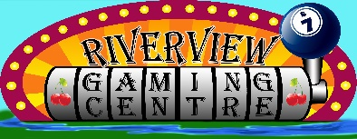
**Please purchase your lunch ticket when you arrive**
Menu is subject to change. If you are going to be late arriving, please call before 11.00
And let us know 519-351-0297

