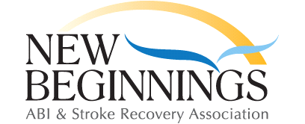 September 2017 Menu – Chatham
1

Club Closed
4  Club Closed | 5  Waffles,  Bacon & Fruit | 6  Sausage and  Perogies | 7  BLT  And Fries | 8  Tacos  And Mexican Rice
11  Breakfast Sandwich  And Hasbrowns | 12  Finger Foods | 13  Chili Dogs | 14  Chicken Burgers & Onion Rings | 15  Fajitas
18  Subs and Chips | 19  Hot Dogs  And Salad | 20  Alfredo Pasta  & Garlic Bread | 21  Meatloaf and Mac n Cheese | 22  Beef Stew  & Roll
25  French Toast, Bacon & Fruit | 26  Chicken Caesar  Salad | 27  Meatballs and  Rice | 28  Grilled Cheese &  Soup | 29  Pizza & Birthday Cake
**Please purchase your lunch ticket when you arrive**
Menu is subject to change. If you are going to be late arriving, please call before 11.00
And let us know 519-351-0297

