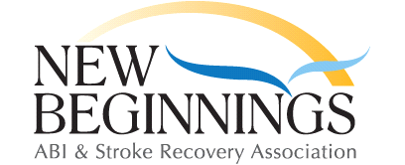 2018 February Menu – Chatham
Due to problems with the
stove menu
may not be as printed
 |  |  | 1  Spaghetti Carbonara | 2  Sausage on a bun  & Veggies
5  BLT & Salad | 6  Bacon & Egg McMuffin with Hash browns | 7  Liver (Pork Chop) & Onions, Fried Potatoes | 8  Pizza Casserole | 9  Fish Sticks  &  Fries
12  Subs & Chips | 13  Mardi Gras  Pancakes, Fruit and Sausage | 14  Valentine’s Day  Dinner  Steak, Baked Potato & Veggies  sign-up required | 15  Spaghetti  & Meat Sauce | 16  Hamburgers  & Onion Rings
19  Club Closed  Family Day | 20  Western Omelet | 21  Roasted Chicken, Mashed Potatoes  & Veggies | 22  Smorgasbord | 23  Pizza & Birthday  Cake
26  Cheesy Potato & Bacon Soup | 27  Eggs Benedict | 28  Pork Roast with Roasted Potatoes & Veggies
**Please purchase your lunch ticket when you arrive**
Menu is subject to change. If you are going to be late arriving, please call before 11.00
And let us know 519-351-0297

